Prelude
Please use this time to prepare your heart and spirit for worship.

There is a prayer station in the northeast corner of the sanctuary. Please use this area at any time during the worship to pray or light a candle for someone.

If you have a prayer request, please fill out a yellow card in the pew. You may pass it toward the center aisle during the singing of the Hymn of Invitation.

Welcome & Announcements

* Songs of Praise
The Heart of Worship CP #77
Just as I Am, Without One Plea #339

Opening Prayer

Children’s Moment Song
Wonderful Words of Life #323

Children’s Moment Gail Rudd
Special Music Kaitlin Thompson
Scripture 1 Corinthians 13:1-10
Sermon “Reckless Love” Kaitlin Thompson

Invitation to Discipleship
If you would like to make a confession of faith or rededicate your life,
please come forward during the singing of the Invitation Hymn
or talk to Pastor Tracy following service.
* Hymn of Invitation 517 (v. 1,2,4)
Love Devine, All Loves Excelling
Pastoral Prayer & Lord’s Prayer (Prayer said with trespasses)

June 24, 2018
Communion Hymn #73
There’s a Wideness in God’s Mercy
Welcome to the Table
Words of Institution
Communion Prayer
Sharing Sacred Meal
We celebrate communion every Sunday. All who believe in Jesus Christ are
welcome to partake of communion. As the bread is passed, please take and
eat. Please reserve the cup. We will share the cup together when instructed.

Gloria Patri #35

Offering (Invitation and Collection)
* Doxology #46
* Prayer of Dedication
* Closing Hymn Screen
Send Me Out

* Benediction
Postlude

* Please stand if you are able

Hearing Assistance: We have hearing assistance units available in the sound booth. Please feel free to get one at the beginning of worship. Please return to sound booth at the end of worship.

Minister: Rev. Tracy Siegman
Worship Leader: Karen Thompson
Guest Musician: Wade Cummins
Elders: Matt Lyons, Roger Byrd
Deacons: Mary Back, Angel Dearth, Heather Lyons, Renee Lyons
Sound & Video Booth: Larry Steele & Connor Thompson

CALENDAR

Today: 9:30 am Sunday School
10:30 am Worship
11:45 am Annual Meeting
Tuesday 7:00 pm Bible Study
Wednesday 2:00 pm Bible Study
Saturday 7:45 am Camp Christian Cleanup Day

Prayer Concerns:



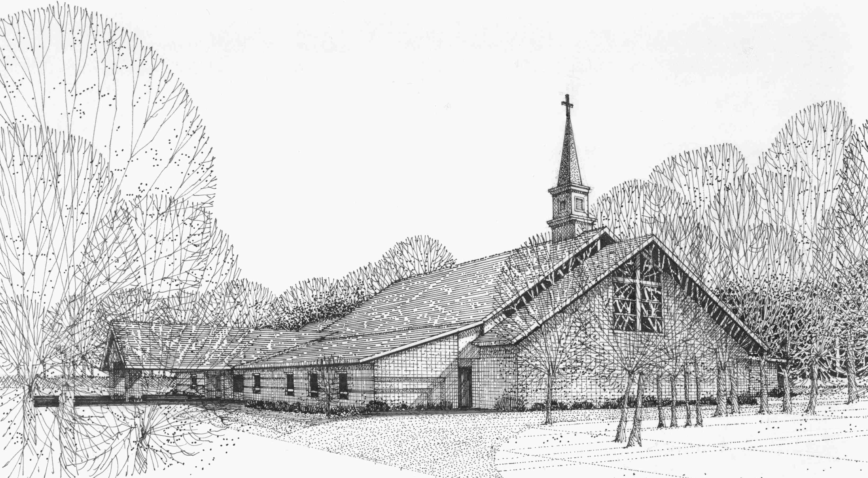

Our Vision
We are the Christian Church (Disciples of Christ) where ALL are welcome. We are faith based, following the teachings of Jesus Christ, and carrying the word to others by serving our community and beyond

First Christian Church, 4520 Rosedale Rd., Middletown, Ohio 45042
Phone: 513-422-2853 Fax: 513-422-4530
fccmiddletownoh@gmail:com
Web Site: www.fcc-middletown.org

